Taking Care of Your Back
By Dennis Payne, PT, DPT, OCS, CSCS

The most common cause of low back pain is postural stress. This is brought on by sitting for a long time in a poor position, poor lifting technique, prolonged forward bending in bad working positions, or standing and lying for a long time in a poor position. Not maintaining good posture and adequate back support can add strain to muscles and put stress on the spine. Over time, the stress of poor posture can change the anatomical characteristics of the spine, leading to the possibility of problems with muscles, discs, and joints, as well as constricted blood vessels and nerves. All of these can be major contributors to back and neck pain.
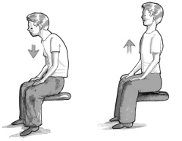
Examples of Bad Posture and Back Support:
- Slouching with the shoulders rounded and head hunched forward
- Carrying something heavy on one side of the body
- Cradling a phone receiver between the neck and shoulder
- Wearing high-heeled shoes or clothes that are too tight
- Keeping the head held too high or looking down too much
- Sleeping with a mattress or pillow that doesn't provide proper back support, or in a position that compromises posture
Correcting poor posture will take some effort and perseverance, and will seem a little unnatural at first. It is typical to feel uncomfortable, and even feel a little taller, but over time the new posture will seem natural and more comfortable.
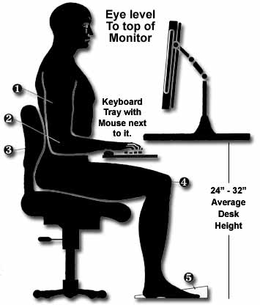
What Is Correct Posture?
Sitting Posture
- Be sure your back is aligned against the back of the chair. Avoid slouching or leaning forward, especially when tired from sitting for long periods
- Be sure your office chair is ergonomically designed to properly support the back and that it is a custom fit
- When sitting on an office chair at a desk, arms should be flexed at a 75 to 90 degree angle at the elbows. If this is not the case, the office chair should be adjusted accordingly
- Knees should be even with the hips, or slightly higher when sitting in the chair
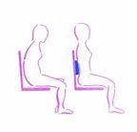
- Keep both feet flat on the floor. If there's a problem with feet reaching the floor comfortably, a footrest can be used along with the chair
- Sit in the chair in an upright position with shoulders and head back and not in a forward and rounded position
- Don't sit in one place for too long, even in ergonomic office chairs that have good back support. Get up and walk around and stretch as needed
- If sitting in an unsupportive chair or on a sofa, use a lumbar roll to keep the natural inward curve of the lower back
- While in a vehicle, the seat should be a proper distance from the pedals and steering wheel to avoid leaning forward or reaching

Standing Posture
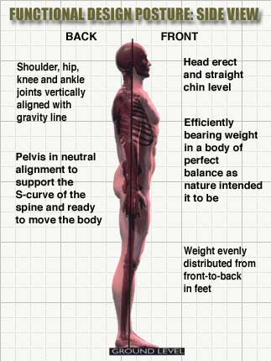
- Stand with weight mostly on the balls of the feet, not with weight on the heels
- Keep feet slightly apart, about shoulder-width
- Let arms hang naturally down the sides of the body
- Avoid locking the knees
- Tuck the chin in a little to keep the head level
- Be sure the head is square on top of the neck and spine, not pushed out forward
- Stand straight and tall, with shoulders upright
- If standing for a long period of time, shift weight from one foot to the other, or rock from heels to toes.

Posture and Ergonomics While Lifting and Carrying
- Always bend at the knees, not the waist. You need to retain the hollow in your low back as you lift. Avoid using the back as a crane to lift the weight.
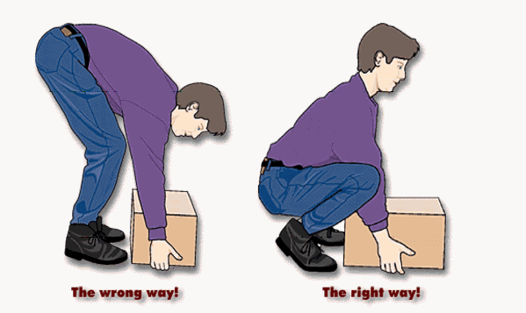
- Stand close to the object and have firm footing with a wide stance
- Use the large leg and stomach muscles for lifting, not the lower back
- When carrying a heavy or large object, keep it close to the chest
- Lift steadily and do not jerk
- Pivot with the feet and avoid twisting
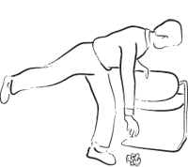
- Push instead of pull whenever possible
- If carrying something with one arm, switch arms frequently
- When carrying a backpack or purse, keep it as light as possible, and balance the weight on both sides as much as possible, or alternate from side to side
- Using a golfer’s lift can minimize stress on the back when picking up light objects or reaching into a trunk, shopping cart, or washer/dryer.

Sleeping Posture with Mattresses and Pillows
- A relatively firm mattress is generally best for proper back support, although individual preference is very important
- Sleeping on the side or back is usually more comfortable for the back than sleeping on the stomach
- Use a pillow to provide proper support and alignment for the head and shoulders
- Consider putting a rolled-up towel under the neck and a pillow under the knees to better support the spine
- If sleeping on the side, a relatively flat pillow placed between the legs will help keep the spine aligned and straight.

